GROUP 8:

|  |  |  |  |
| --- | --- | --- | --- |
| No | *Members:* | ID | *Participation* |
| 1 | Nguyễn Thanh Tịnh (leader) | 21110804 | 100% |
| 2 | Nguyễn Ngọc Mạnh | 21110781 | 100% |
| 3 | Đỗ Huỳnh Bảo Đăng | 21110764 | 100% |
| 4 | Nguyễn Duy Mạnh | 21110780 | 100% |

HOW TO INSTALL PROJECT

DOWNLOAD:

* JDK 17: <https://www.oracle.com/java/technologies/javase/jdk17-archive-downloads.html>

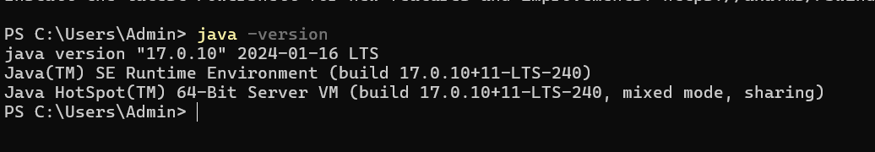

* Eclipse: Eclipse web application
* Tomcat 9: <https://tomcat.apache.org/download-90.cgi>
* Database: MySql

INSTALL:

Database :

* Backup dump file sql in the file “Dump20240424” in mysql: Create database “finalweb” and then import data in the administration  
  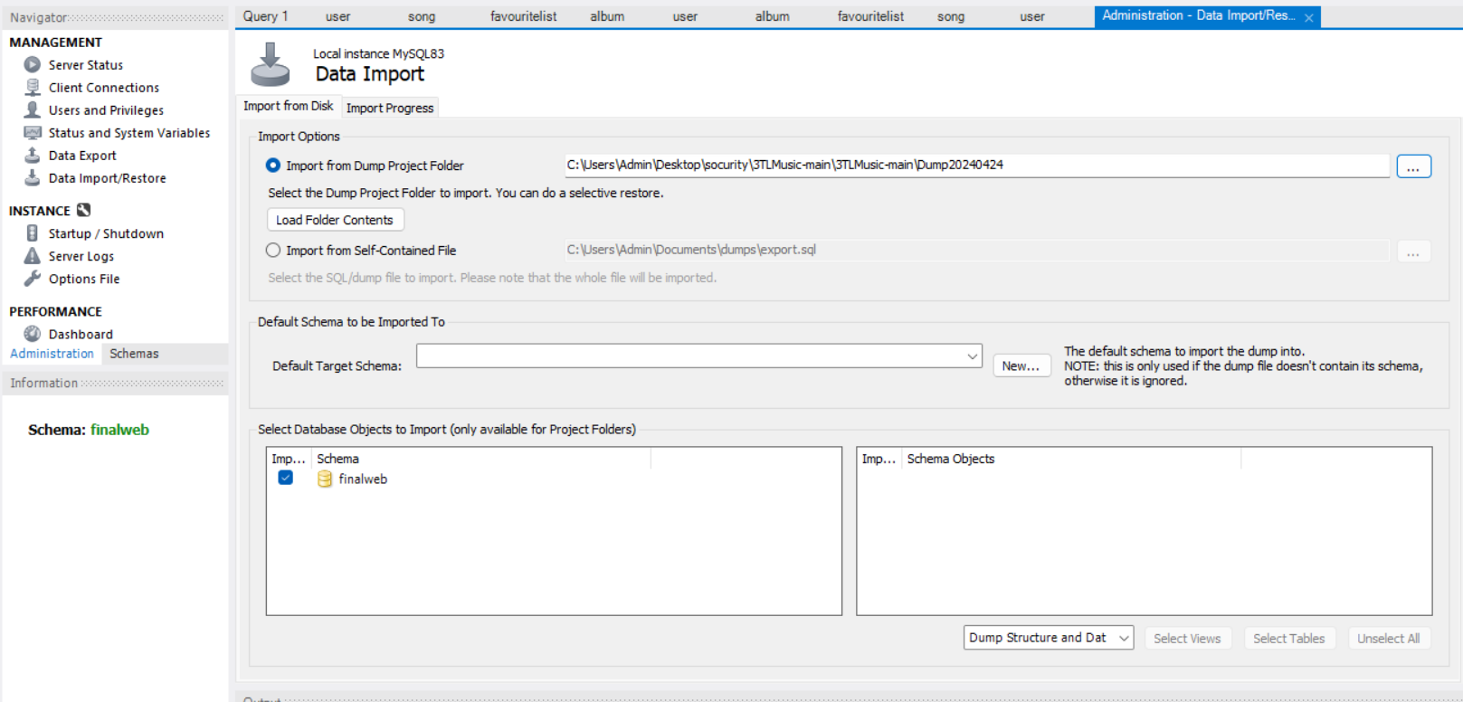

ECLIPSE:

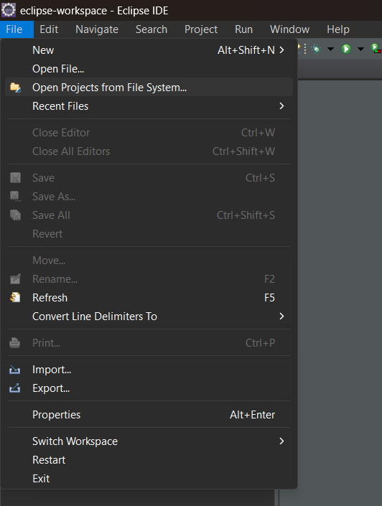

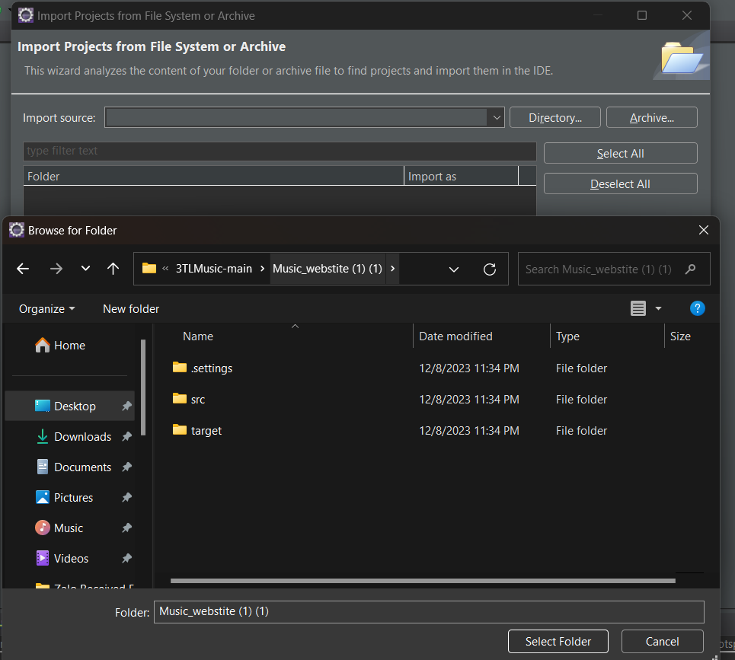

How to setup persistence.xml

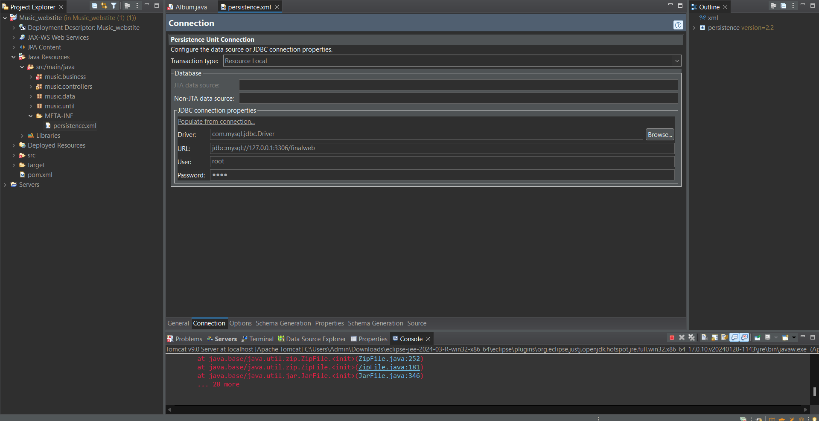

Connect the user and password with the mysql workbench like the picture below

